ISTE-Data Warehousing PE04

Team # 1 Name(s): Ellie Parobek, John Warner  
**PE04: Dimensional Modeling Exercise**

**Overview**

In this exercise, you have an opportunity to investigate an approach for scoping and designing a set of data marts, which logically form a warehouse, starting from the source operational data systems in a realistic business scenario. This is a composite exercise, composed of six (6) separate individual exercises labeled: Exercise 1, Exercise 2, ..., Exercise 6.

**After completing this exercise, you should be able to:**

- Review data values from source operational systems to determine their potential use in a data mart/data warehouse.

- Identify possible dimensions and fact groups.

- Design a set of dimensions by identifying dimension attributes and any hierarchies. - Design a set of fact groups.

- Use a matrix tool, called a Data Mart Matrix, to identify dimensions that need to be

conformed across data marts.

- Design a STAR schema for a fact group.   
**Business Scenario**

You are working in the IT department of TelComprehensive Inc., a large, multinational telephone company. The company provides telecommunications service, both land based and cellular, to customers across the Western Hemisphere. Your team has been asked to build a set of conformed data marts for an overall data warehouse development project.

The company keeps track of the following corporate-wide processes:   
- Customer service and billing inquiries

- Customer billing

- Equipment installation and service

- Yellow page advertising

- Marketing

- Call detail (billing perspective)

Call detail (network switching perspective)

- Customer inventory (phone equipment, Centrex systems, features)

Network equipment inventory (switches, lines, etc)

- Real estate inventory (poles, buildings, etc)

Employees and payroll

Computer system job processing &

chargeback Purchase orders to suppliers

Deliveries from suppliers

ISTE-Data Warehousing PE04

For this phase of the development, data marts will be sourced from three (3) main operational systems:

**Call Detail Tracking** This system records the details about the individual phone calls made by the company’s customers. Information is maintained

in the following categories:

• The customer: home address and the billing address

• The call: when, from where, to whom, how long the call

lasted

• Any phone service, i.e. “product,” provided by type, class

and product group

• Pricing: the pricing package to which the call applies, rates,

any special discounts that apply (daytime, evening,

weekend)

**Service Call Tracking** This system keeps track of the details related to the calls for repair services from the company’s customers. Information is

maintained in the following categories:

• The service call: problem categorization, call request and

resolution dates, the number of days required to resolve the

problem, the number of customer calls related to this

problem, and the status of the service request (open; closed)

• The employee who handled the call: name, address and

demographic information, employment information

• The cost center1 that handled the service request

• The customer who placed the service request: name, address

**Materials Inventory** Since this is a service business, this inventory system focuses on the supplies and spare parts used in their service calls. They do

not re-manufacture or resell the items that they purchase for this

purpose.

This system allows the company to evaluate their inventory

situation at an individual item basis and to establish policies for

the efficient control of inventory levels. It includes:

• Information about items used for service/repair: the

categorization of each item, when it was purchased, the

quantity currently on hand, the quantity on order, and a

target “optimum” inventory level

• The buyer who purchases the items for the company

• The cost center that uses these items and where it fits within

the corporate hierarchy

Details about the meaning and data formats of the data values sourced from these systems are shown on the following pages.

1 For the purposes of this scenario, a cost center is a business entity – i.e. a department or a division – that has a budget, that maintains information pertinent to cost generation, and that the ability to track and control those costs. While they add to the operational costs of the organization they do not directly add to the profits. Examples are Research and Development, Marketing, and Customer Service, etc.

ISTE-Data Warehousing PE04

Dimensional Modeling Exercise 1: Identifying Facts and Dimensions

- Suppose you are employed by a large telephone company, and your task

is to build the data marts for the overall data warehouse

- You will be extracting data from three operational systems

- Identify each field

D - a dimensional attribute

F - a fact

O - operational only, not to be included

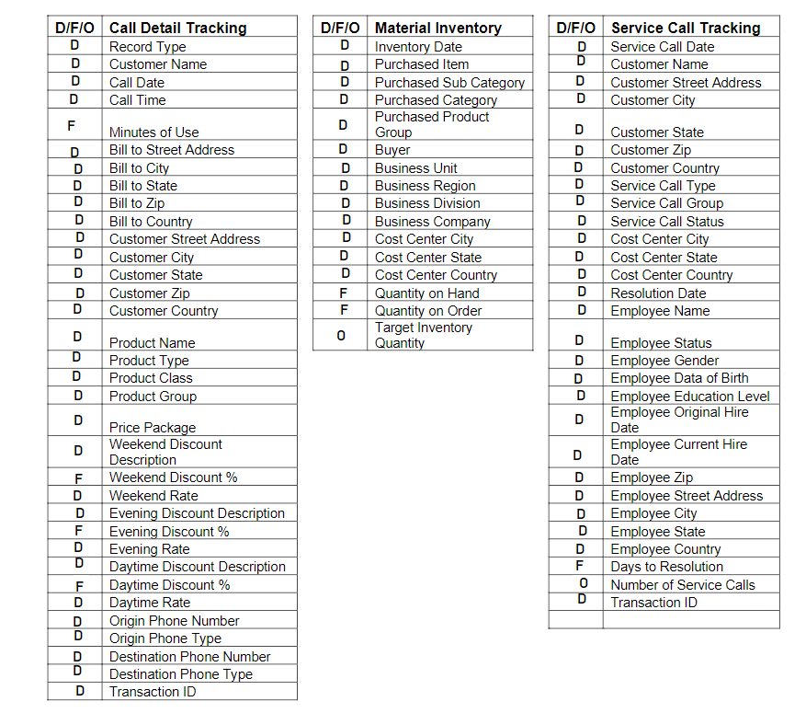

ISTE-Data Warehousing PE04

Dimensional Modeling Exercise 2: Identifying Dimensions and Fact Groups

Using the same extract files, identify

- Possible dimensions

- Possible fact groups

**Possible Dimensions**

Call Detail Date___________________________________________________________________

Customer________________________________________________________________________

Product__________________________________________________________________________

Call Detail_______________________________________________________________________

Service Call Date__________________________________________________________________

Service Call Resolution Date_________________________________________________________

Employee________________________________________________________________________

Cost Center_______________________________________________________________________

Material Inventory Date_____________________________________________________________

Purchase_________________________________________________________________________

**Fact Groups**

Price Package____________________________________________________________________

Service Call______________________________________________________________________

Material Inventory_________________________________________________________________

ISTE-Data Warehousing PE04

Dimensional Modeling Exercise 3: Designing Dimensions

Design each of the dimensions that were identified in Exercises 1 & 2.

- Identify dimension attributes

- Identify all hierarchies of attributes within a dimension

Call Detail Date -> Year, Month, Day, Hour, Minute, Second

Customer -> Country, State, City, Zip, Street Address

-> Billing Country, Billing State, Billing City, Billing Zip, Billing Street Address

Product -> Name

-> Type

-> Group, Class

Call Detail -> Record Type

-> Origin Phone Number

-> Origin Phone Type

-> Destination Phone Number

-> Destination Phone Type

Service Call Date -> Year, Month, Day

Service Call Resolution Date -> Year, Month, Day

Employee -> Name

-> Status

-> Gender

-> Date of Birth

-> Education Level

-> Original Hire Date

-> Current Hire Date

-> Country, State, City, Zip, Street Address

Cost Center -> Business Unit, Business Region, Business Division, Business Company

-> Country, State, City

Material Inventory Date -> Year, Month, Day

Purchase -> Group, Category, Sub-Category, Purchased Item

-> Buyer

ISTE-Data Warehousing PE04

Dimensional Modeling Exercise 4: Designing Fact Groups

Design each of the fact groups that were identified in Exercises 1 & 2.

**Fact Group:** Price Package_________________________________________________

|  |  |  |
| --- | --- | --- |
| Fact Name | Fact Description | Default Aggregation Rule |
| Weekend Discount Percent | Details the specific terms and conditions associated with weekend usage. | Semi-additive over time |
| Evening Discount Percent | Details the specific terms and conditions associated with evening and holiday usage | Semi-additive over time |
| Daytime Discount Percent | Details the specific terms and conditions associated with daytime usage | Semi-additive over time |
| Minutes of Use | The total number of minutes for this call | Sum |

**Fact Group:** Service Call___________________________________________________

|  |  |  |
| --- | --- | --- |
| Fact Name | Fact Description | Default Aggregation Rule |
| Days to Resolution | The total number of days from the date the service call was opened to the date that the service call was closed | Semi-additive over time |

**Fact Group:** Material Inventory______________________________________________

|  |  |  |
| --- | --- | --- |
| Fact Name | Fact Description | Default Aggregation Rule |
| Quantity on Hand | Indicates the number of units of this product that are available on site at this organization location | Semi-additive over time |
| Quantity on Order | The number of units of this product that have been ordered, but have not yet been shipped | Semi-additive over time |

ISTE-Data Warehousing PE04

Dimensional Modeling Exercise 5: Create the Data Mart Matrix

The data mart matrix shows the relationship between the possible data marts and dimensions. Any dimension (column) with more than one X implies that this dimension must be conformed across multiple data marts in order to fit into the Data Warehouse Bus Architecture. Fill in the data mart matrix using the following format:

|  |  |  |  |  |  |  |  |  |  |  |
| --- | --- | --- | --- | --- | --- | --- | --- | --- | --- | --- |
| **Fact Groups** | Call Detail Date | Customer | Product | Call Details | ServiceCall Date | Service Call Resolution Date | Employee | Cost Center | Material Inventory Date | Purchase |
| Price Package | **X** | **X** | **X** | **X** |  |  |  |  |  |  |
| Service Call |  | **X** |  |  | **X** | **X** | **X** | **X** |  |  |
| Material Inventory |  |  |  |  |  |  |  | **X** | **X** | **X** |

ISTE-Data Warehousing PE04

Dimensional Modeling Exercise 6: Logical Table Design

- Use the dimensional model that you have created so far

- Design the actual star schema for the fact groups

Create your Dimensional Model using MySQL Workbench, save it as a pdf file, and one member from each team to submit it to MyCourses PE04 Drop Box. And bring a hard copy of the pdf file to next class.

Each team member should submit a peer evaluation form to the dropbox. No PE04 grade without the Peer Evaluation form submitted. The form is available on MyCourses.

